
LOYOLA JESUIT SECONDARY SCHOOL
2026 MALAWI SCHOOL CERTIFICATE OF EDUCATION
MOCK EXAMINATION
MATHEMATICS
Subject Number: M131/II

Thursday, 20 February Time Allowed: 2 h 30 mins
8:00 -10:30 am
PAPER II
(100 marks)

Instructions
- This paper contains 17 printed pages. Please check.

- Answer all the six questions in Section A and any four questions from section B.

- The maximum number of marks for each answer is indicated against each question

- Write your answers in the spaces provided on the question paper

- Calculators may be used

- All working must be clearly shown

- Write your ID at the top of each page of your question paper in the spaces provided

- In the table provided on this page, tick against the Number you have answered

Question Number | Tick if answered | Do not write in these columns
1
2
3
4
5
6
7
8
9
10
11
12

Section A (60 marks)
Answer all the six questions in this section.
- a. A bag contains 7 bean seeds, 5 groundnut seeds and 8 maize seeds. If a seed is picked from the bag at random, what is the probability of getting at groundnut seed? (3 marks)

  - Given that $\vec{AB}=\left(\begin{matrix}5 \\ -1\end{matrix}\right)$ and $\vec{AC}=\left(\begin{matrix}3 \\ 7\end{matrix}\right)$. Find $\left|\vec{BC}\right|$ and leave the answer in surd form. (5 marks)

- a. Without using a quadratic formula solve the equation $x^{2}+5x-1=0$. Correct your answer to 2 decimal places (6 marks)

  - The time, T, it takes to enter a stadium is partly constant and partly varies as the number of people (N) entering the stadium. If there 4 people it takes 12 seconds to enter the stadium and if there are 5 people it takes 14 seconds. How long will take, if there are 28 people entering the stadium. (5 marks)

- a. Figure 1 shows a circle FGHJ with centre O. FG is parallel to OH and FOJ is a diameter.

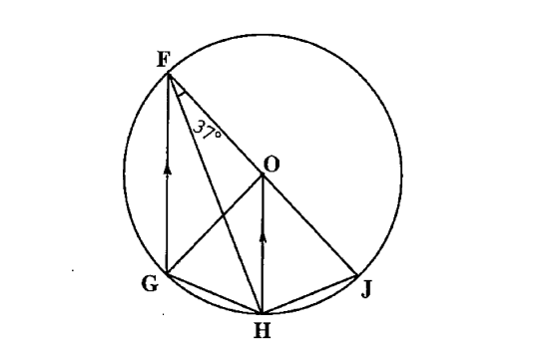
Figure 1

If angle HFJ$=37°$, calculate angle GHF (5 marks)

  - Suppose $y-ax=x+5$ and $y+2x=0$ are two parallel straight lines, calculate the value of $a$. (5 marks)

- a. Solve the simultaneous equations (6 marks)
$$x^{2}-y-5=0$$
$$\frac{1}{2}y-x=-1$$

  - The areas of two similar triangles are $64{cm}^{2}$ and $36{cm}^{2}.$ The base of the bigger triangle is 16$cm$. Calculate the corresponding height of the smaller triangle. (5 marks)

- a. Figure 2 below is a Venn diagram
$$x$$
$$y$$
1
$$x-3$$
$$y-1$$
6
$$x+3$$
C
A
B
Figure 2
Given that $n\left(A∩B\right)=9$ and $n((A∪B)∩C))=13,$find $n(A'∩C)$ (5 marks)

  - Figure 3 below is pipe of outer radius $R=4cm$ and height, $h=12cm$
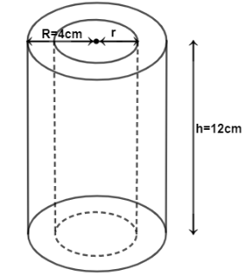
Figure 2
If inner radius, $r=3.5cm$, find volume of the material used to make the pipe. (6 marks)

- A boat travels from port A to port B on a bearing of 040°, covering a distance of 76 km. From port B, it then changes direction and travels on a bearing of 120° for 92 km to reach port C. Find the bearing of port A from port C. (9 marks)

Section B (40 marks)
Answer any four questions from this section

- The table below shows the marks scored by learners in a test.
Marks | 10 | 11 | 12 | 13 | 14 | 15
Frequency | 2 | 2 | 4 | 12 | 6 | 4
Find standard deviation of the marks correct to 3 significant figures (10 marks)

- a. A man at the top of the of a building observes a car moving in a straight road towards the building. Initial position of the car was A and after 10 seconds, the car was position B. The angles of depression of A and B were $30°$ and $60°$ respectively. If the height of the building is 120 metres, calculate distance between A and B. (5 marks)

  - Find the area of the triangle in figure 4 below (5 marks)
A
B
C

$$70°$$
$$6 cm$$
$$11 cm$$
Figure 4

- a. A motorist travels on average speed of 80km/h for the first 60km of a journey. If she travels at an average speed of 96 km/h for next 120km, find her average speed for the whole journey. (4 marks)

  - The sum of the three positive numbers which are in a GP is 105. The square of the second number is equal to five times the third number. Find the second term of the progression. (6 marks)

- a. The probability of having a lunch on time at a boarding school is $\frac{4}{5}$. When the lunch is
on time, the probability of having beef is $\frac{3}{10}$ and when late, the probability of having
beef is $\frac{5}{8}$.
    - Draw a tree diagram to represent this information by completing all branches. (3 marks)

    - Use your tree diagram to find probability of having beef. (2 marks)

- Figure 5 shows a parallelogram ABCD in which $\vec{AB}=\underline{x}$ and $\vec{BC}=\underline{y}$.
.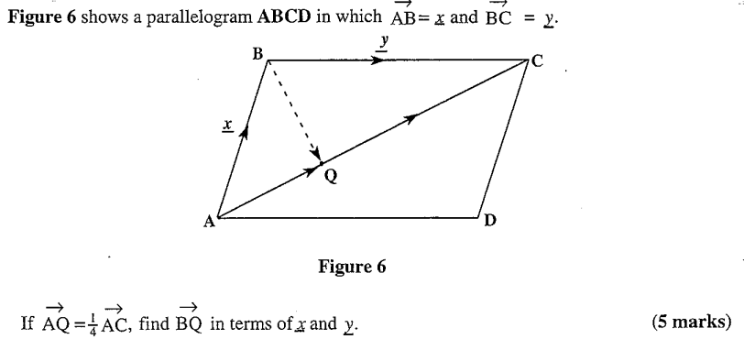
Figure 5
If $\vec{AQ}=\frac{1}{3}\vec{AC}$, find $\vec{BQ}$ in terms of $\underline{x}$ and $\underline{y}$ (4 marks)

- a. Copy and complete the table of values for the equation $y=(x+2)(x-1)(x-3)$

$$x$$ | $$-3$$ | $$-2$$ | $$-1$$ | $$0$$ | $$1$$ | $$2$$ | $$3$$ | $$4$$
$$y$$ | $$-24$$ | $$0$$ | $$8$$ |  | $$0$$ |  | $$0$$ | $$18$$
  - Using a scale of 2 cm to represent 1 unit on horizontal axis and 2 cm to represent 5 units on vertical axis, draw a graph of $y=(x+2)(x-1)(x-3)$
  - Use your graph to solve the equation of $x^{3}-2x^{2}-6x+6=$0 (10 marks)

- A company hires two types of minibuses A and B to carry its 128 employees to work each day. Type A carries 16 passengers and type B carries 8 passengers. The company can hire at most 10 minibuses in total.
- If $x$ represents number of the type A minibus and $y$represents number of type B minibuses, write down all the four inequalities.

- Using a scale of 2 cm to represent 2 units on both axes, draw graphs to show the region represented by the inequalities

- Use your graph to find the number of minibuses of each type the company must hire to meet its target of transporting 128 employees at once using a minimum number of type A minibuses. (10 marks)


End of question paper

